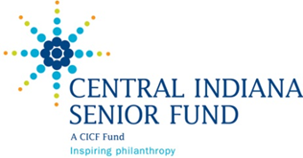

2015 CISF Proposal Concept Form

Please complete the proposal concept form for the Central Indiana Senior Fund. Keep the proposal concept to less than two pages.

Email the completed form to Alyse Vail at [alysev@cicf.org](mailto:alysev@cicf.org) no later than midnight, May 29th of 2015.

Organization Information

|  |  |  |  |
| --- | --- | --- | --- |
| Organization name |  | | |
| Contact person |  | Title |  |
| Email |  | Phone |  |
| Date submitted |  | | |

Proposal Concept

|  |  |  |  |
| --- | --- | --- | --- |
| Proposal concept title: |  | | |
| Type of funding requested: | Operating  Programming/Project  Capacity Building  Other: | | |
| Primary impact area: | Basic Needs  Health & Wellness  Life Affirming Opportunities  Living Environment of Choice | | |
| Total Number of Seniors to be Served: |  | Percentage of overall organization population served that is 55+: |  |
| Estimated total cost of proposal concept: |  | Estimated request to  the Central Indiana Senior Fund: |  |

Most recent year your organization was funded by the Central Indiana Senior Fund:

|  |
| --- |
| Briefly describe the proposal concept  Include the need(s) and opportunities addressed and who will be served |
| Briefly describe the proposed outcomes  The Central Indiana Senior Fund is interested in knowing what your organization hopes to accomplish related to the proposal concept.  Describe what will change, increase, decrease, or be different for the participants because of this funding. |